Tutorial: 8

Name: Chalani Saumya Rajapakshe

Id: IT21377280

Exercise- 01

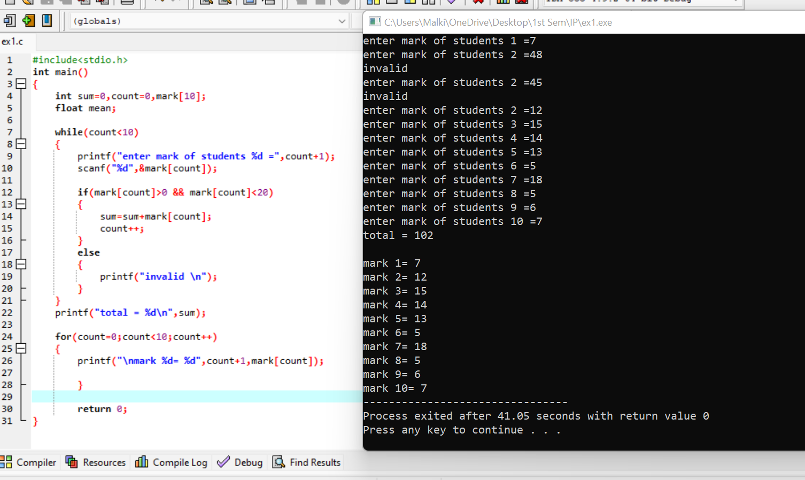

#include<stdio.h>

int main()

{

int sum=0,count=0,mark[10];

float mean;

while(count<10)

{

printf("enter mark of students %d =",count+1);

scanf("%d",&mark[count]);

if(mark[count]>0 && mark[count]<20)

{

sum=sum+mark[count];

count++;

}

else

{

printf("invalid \n");

}

}

printf("total = %d\n",sum);

for(count=0;count<10;count++)

{

printf("\nmark %d= %d",count+1,mark[count]);

}

return 0;

}

Exercise- 02

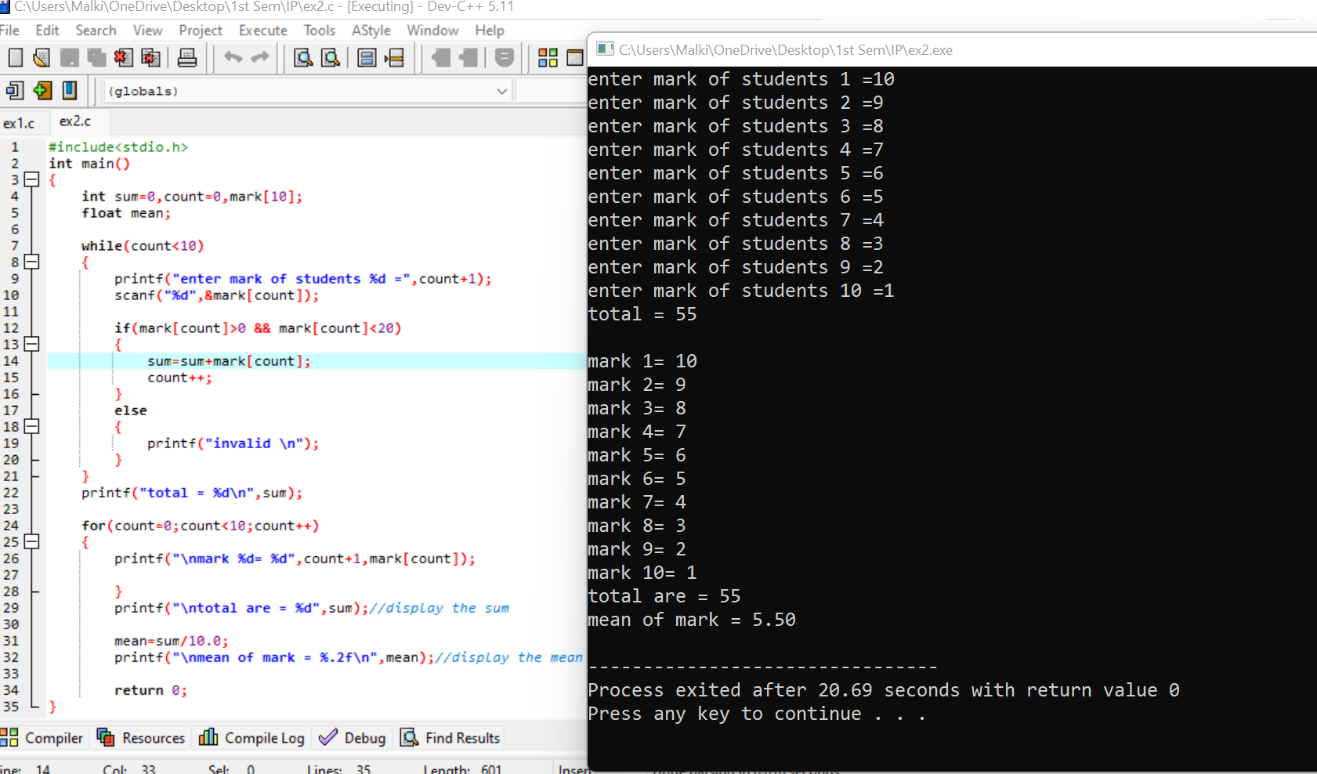

#include<stdio.h>

int main()

{

int sum=0,count=0,mark[10];

float mean;

while(count<10)

{

printf("enter mark of students %d =",count+1);

scanf("%d",&mark[count]);

if(mark[count]>0 && mark[count]<20)

{

sum=sum+mark[count];

count++;

}

else

{

printf("invalid \n");

}

}

printf("total = %d\n",sum);

for(count=0;count<10;count++)

{

printf("\nmark %d= %d",count+1,mark[count]);

}

printf("\ntotal are = %d",sum);//display the sum

mean=sum/10.0;

printf("\nmean of mark = %.2f\n",mean);//display the mean

return 0;

}

Exercise- 03



#include<stdio.h>

int main()

{

int Motion[5],j,temValue;

for(j=0;j<5;++j)

{

printf("Enter the value %d: ",(j+1));

scanf("%d",&Motion[j]);

}

printf("Original array:\n");

for( j=0;j<5;++j)

{

printf("%d ",Motion[j]);

}

temValue = Motion[0];

for ( j = 0; j < 4; j++)

{

Motion[j] = Motion[j + 1];

}

Motion[4] =temValue;

printf("\n\nArray after rotation by one position in the forward direction =\n");

for(j=0;j<5;++j)

{

printf("%d ",Motion[j]);

}

getchar();

getchar();

return 0;

}

Exercise- 04



#include <stdio.h>

#include <stdlib.h>

#include <ctype.h>

void main( void){

int values[]={0,0,0,0,0,0,0,0,0,0,0,0,0,2,0,0,0,0,0,0,1,1,1,2,2,2,2,2,2,2,2,2,2,2,2,2,2,3,3,3,3,3,3,3,

4,4,4,4,4,4,4,4,4,4,4,5,5,5,5,5,5,5,5,5,6,6,6,6,6,6,6,6,6,6,6,6,6,7,7,7,7,7,8,8,8,8,8,8,8,8,8,8,8,8,8,8,8,8,8,9};

int counterValues[10]={0};

int i,j;

for(i=0;i<sizeof(values)/sizeof(values[0]);i++){

counterValues[values[i]]++;

}

for(i=0;i<10;i++){

printf("%d %d ",i,counterValues[i]);

for(j=0;j<counterValues[i];j++)

printf("\*");

printf("\n");

}

getchar();

getchar();

}